**Benefits and ethical issues of using AI in Agriculture in South Africa**

Leukemans, Byron 11A

Roosevelt High School   CAT PAT 2023

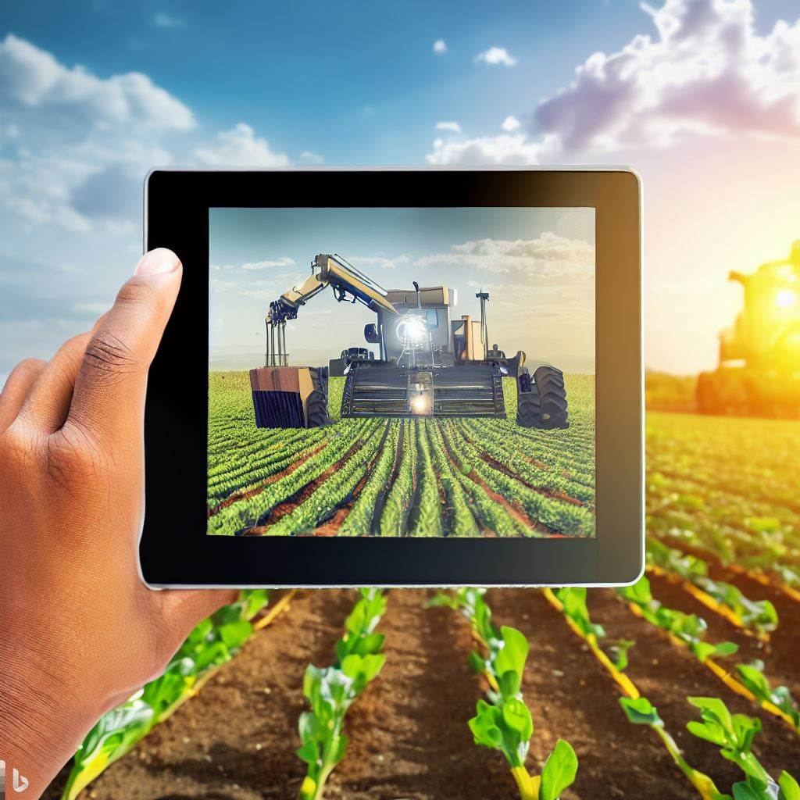

Table of Contents

Folder Structure 1

Focus Question: How AI benefits and effects Agriculture in South Africa 2

How would future technology of AI benefit Agriculture in South Africa? 2

Task Definition 3

➢ What is the current Situation? 3

➢ What will the focus and purpose of my investigation be? 3

➢ How will I go about conducting the investigation, considering the PAT requirements? 3

➢ Who is the information for? 3

Summaries 4

4

➢ 1.How can Farmers apply AI to farms to be used every day? 4

➢ 2.What are the potential risks when using this type of AI in agriculture in South Africa? 4

➢ 3.How can this benefit South African farmers? 4

➢ 4.Why do we need AI (specifically for agriculture)? 5

➢ 5.How will this shape our long – term future for South Africa? 5

➢ 6.Typical AI jobs created? 5

➢ 7.How can we ensure that no-one is left behind? 5

➢ 8.What must be considered when implementing this type of AI? 6

➢ 9.Do you think this type of AI will affect farmers positively or negatively? 6

➢ 10.Do you believe that in a country like South Africa that technology such as the above mentioned is possible (and if so substantiate)? 6

Summaries from spreadsheet and Database 7

➢ Spreadsheet 7

➢ Database 7

Bibliography 6

Bibliography continued… 7

Bibliography Continued… 7

Appendices: Addendum A: Questions & Sources table i

Appendix A continued… ii

Appendix A: Assessment summary iii

Appendix B iv

Appendix B:Continued… v

My Verdict on the topic vi

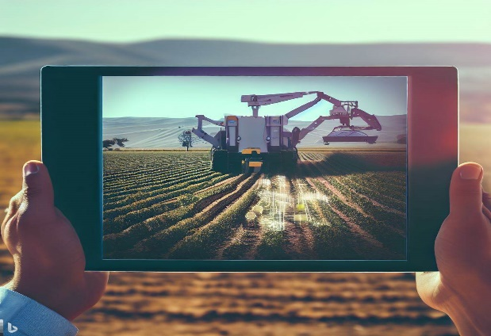

Figure Example of what AI in agriculture in South Africa could look like.

# Folder Structure

# Focus Question: How AI benefits and effects Agriculture in South Africa

### How would future technology of AI benefit Agriculture in South Africa?

"‘n Boer maak ‘n plan” is a famous Afrikaans proverb that encloses the resourcefulness and ingenuity of South African farmers. In today's rapidly advancing world, where technology plays a pivotal role in driving progress, this age-old saying holds more relevance than ever. As South Africa seeks innovative solutions to address the challenges of food security, sustainability, and efficiency in the agricultural sector, the emergence of Artificial Intelligence (AI) promises to be a game-changer.

Now I know that this form of technology has only been shown in video games and television, but as times goes on it is becoming more of a reality. Let us first describe what AI is: AI, or Artificial Intelligence, refers to the development of computer systems that can perform tasks typically requiring human intelligence. It involves creating intelligent machines that can learn, reason, and make decisions based on data and patterns. AI includes techniques like machine learning, deep learning, natural language processing, computer vision, robotics, and expert systems. It aims to mimic human cognitive abilities and enable machines to understand, adapt, and perform specific tasks autonomously.  
 Now without further to do let’s get straight into the topic ‘How AI will benefit  
the agriculture sector in South Africa.

The idea of AI doing mundane work in the agriculture sector might still be new to the tongue, and many Greta Thunberg’s would also want their say in this too, but perhaps a new form of technology would just be the new thing that South Africa needs. Let’s look at the benefits:

* It is a known fact that AI taking part in agriculture would decrease human error and increase profits made by farmers
* They are also more reliable
* They can work 24/7
* Lastly, they can work more efficiently and accurately with prescient, enhancing better results for the farm.

These are just a few to mention, but again comes the question on how it would help South Africa and its people:

* Yield prediction – The implementation of AI in agriculture will allow AI to analyse historical data, weather patterns and conditions to accurately forecast yields. In result this will allow farmers to plan their operations and better time themselves.
* Precision farming – AI powered systems can analyse real-time data from sensors as well as satellite imagery to provide farmers with soil compositions, moisture levels and crop health. This enables a more precise version of farming compared to humans. This can increase efficiency on the farm enabling reduced costs due to human error occurring.

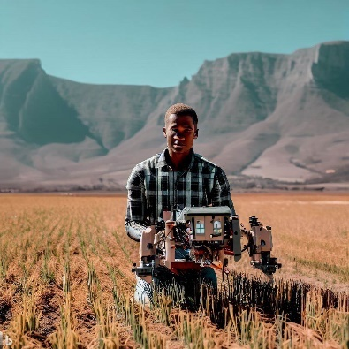

Figure Example of what automation on the farm could look like.

* Automation – Robots and drones can automate tasks such as planting or fertilising. This reduces manual labour and enables more accuracy on the farm.
* Digital platforms – AI technologies allows users to interact with their equipment on a digital platform such as their smartphone and allows it to be activated anywhere with a single tap. This allows farmers to access their farms anywhere in the world.

However just like anything in the world there are limitations and issues about AI in South Africa:

* Data collection – Using AI requires large amount of data collection and may in some cases lead to famers in poverty-stricken areas, those with poor internet may struggle with the collection and management of such necessary data.
* Limited access to technology – Many farmers especially those in rural areas in South Africa will have a lack of technology to implement this sort of technology. Not only that, but some rural areas also have difficulty with internet connectivity which will also make it nearly impossible for these farmers.
* High cost to implement – AI technology can sometimes cost a lot of money to implement, and living in a country where costs are very high, causing many small-scale farmers to find it very difficult to implement such new development. s
* Inaccuracy – Even though many believe that AI can never make mistakes, it is however possible in some instances, where AI methods can get mixed up leading to a loss in the business.

Now that we have discussed what AI is and the benefits as well as the issues about AI in the agricultural sector in South Africa, let us dive deeper on how AI would affect the agricultural sector.

.

# Task Definition

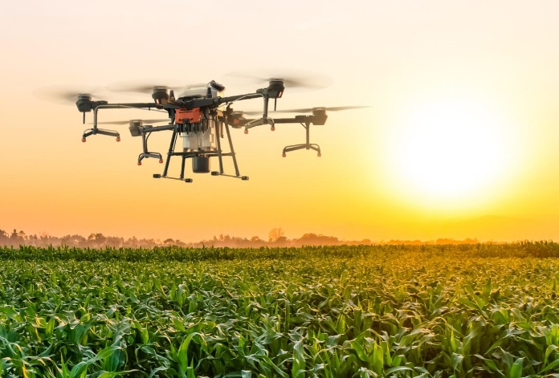

Figure Image of DJI drone working on the farm. Taken from DJI.com

## What is the current Situation?

**Answer:** The current situation about the use of AI in the agricultural sector in South Africa is gradually becoming a reality. While the use of AI in agriculture is still relatively blank compared to other sectors, there are some notable developments and initiatives taking place in the country including: precision farming, better livestock management, yield prediction and automated tasks.

## What will the focus and purpose of my investigation be?

**Answer:** The primary aim of my investigation is to analyse the advantages and challenges associated with the implementation of AI in the agricultural sector of South Africa. Additionally, a meticulously designed questionnaire will be administered to gather valuable insights and perspectives from stakeholders about their opinions on the use of AI in agriculture. The central focus of this investigation lies in assessing the potential superiority of AI over human interventions in agricultural practices.

## How will I go about conducting the investigation, considering the PAT requirements?

**Answer:** For this study, a comprehensive analysis will be conducted by referring to multiple sources to examine the impact of AI on the agricultural sector in South Africa. The report will incorporate findings from well-established sources to ensure the reliability and credibility of the information presented. Additionally, a questionnaire will be created to gather insights and opinions about the potential benefits of AI in the South African agricultural industry. The combination of sturdy research and survey data will supply a comprehensive understanding of the topic and ease informed conclusions, which will be presented at the end of this task.

## Who is the information for?

**Answer:** The information sourced in this report is aimed at those who are looking for a change in the developing agriculture sector and how AI will play a lead role as we prepare ourselves to enter the 4th industrial revolution.

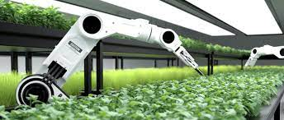

Figure AI robot working in a greenhouse doing human work

# Summaries

# 

Figure Example of using AI in everyday use, taken from the Afrikaans TV show 'Nisboere' featuring Anrich Herbst

## 1.How can Farmers apply AI to farms to be used every day?

Farmers can use AI in their everyday farming activities to improve productivity to their operations. AI can analyse several types of data such as satellite images, weather patterns, and soil sensor readings to supply useful information about crops and soil. By using this information, farmers can make smarter decisions, such as when to water their crops, find and manage diseases and pests, and decide the best time to plant and harvest. AI-powered drones and robots with sensors and cameras can collect data on crop health and soil conditions, allowing farmers to target specific areas that need attention. AI can also help predict crop yields, select the right crops, and manage resources efficiently. Additionally, AI can check the health and behaviour of livestock, perfect the supply chain, improve agricultural machinery, and supply automated systems to manage farm tasks. By embracing AI, farmers can boost efficiency, productivity, and sustainability in their everyday farming practices.

## A robot holding a tomato Description automatically generated2.What are the potential risks when using this type of AI in agriculture in South Africa?

Figure 6 Example of potential risk when using AI which is the replacement of jobs

When using AI in agriculture in South Africa, there are several potential risks that need to be considered. Firstly, not all farmers may have easy access to or be able to afford AI technology, creating a divide between those who can receive help from it and those who cannot. Additionally, there are concerns about data privacy and security, as AI relies on collecting and analysing enormous amounts of data. Farmers must ensure that their data is protected from unauthorized access. Another risk is the dependence on technology, as reliance on AI systems can leave farmers vulnerable to technological failures, such as power outages or software glitches. It is important to have backup plans in place. Skills and training are also crucial, as farmers need to buy the necessary ability to effectively use and keep AI systems. Bias in AI algorithms is another concern, as biased data can lead to unfair outcomes or decisions. Ethical considerations, including animal welfare and environmental impact, need to be addressed as AI becomes more prevalent. Regulatory and legal challenges, such as data ownership and liability, should also be carefully considered. By being aware of these risks and acting appropriately, stakeholders can ensure that the use of AI in agriculture helps all farmers and contributes to sustainable and fair practices in South Africa.

## 3.How can this benefit South African farmers?

AI offers several benefits to South African farmers. It helps them make informed decisions by analysing data on weather, soil conditions, and market trends. This leads to improved productivity and profitability. AI automates tasks like crop monitoring, reducing manual labour and allowing farmers to focus on critical activities. Precision agriculture techniques using AI minimize resource waste by targeting specific areas in fields that require attention. AI aids in disease and pest management by quickly detecting and addressing issues, preventing crop losses. Livestock monitoring using AI ensures animal health and perfects breeding programs. AI predicts market trends and crop yields, aiding farmers in planning and maximizing profitability. Moreover, AI supports sustainable agriculture practices by perfecting resource usage and reducing environmental impact. Overall, AI empowers South African farmers with data-driven decision-making, boosting productivity, and promoting sustainability.

## 4.Why do we need AI (specifically for agriculture)?

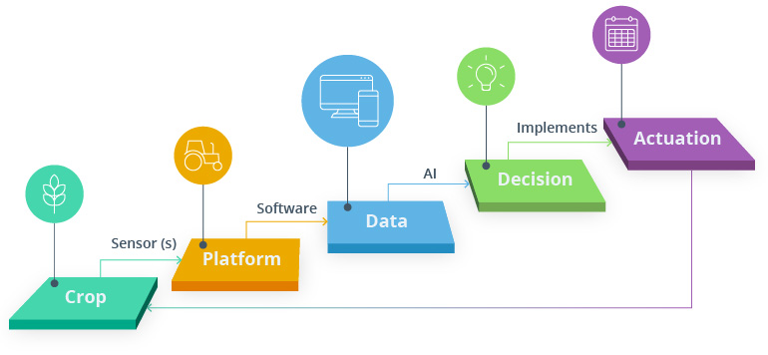AI is essential in agriculture for several reasons. It enables farmers to analyse large amounts of data and gain valuable insights for informed decision-making. AI allows for precise and targeted interventions, minimizing resource waste and perfecting efficiency. Automation powered by AI reduces manual labour and improves productivity. AI's predictive analytics aid in planning and maximizing profitability. It aids in early detection of crop diseases and pests, leading to effective management strategies. Moreover, AI promotes sustainable practices by perfecting resource usage and reducing environmental impact. Overall, AI enhances productivity, efficiency, and sustainability in agriculture.

Figure Example how AI will transfer data to farmers

## 5.How will this shape our long – term future for South Africa?

AI has the potential to shape South Africa's long-term future by increasing agricultural productivity, promoting sustainable practices, improving efficiency and decision-making, fostering technological advancements and innovation, and creating new job opportunities. It can contribute to the overall growth, resilience, and competitiveness of South Africa's agricultural sector in the years to come.

## 6.Typical AI jobs created?

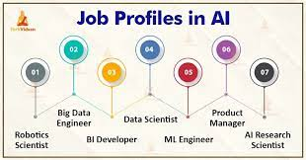Typical AI jobs created in agriculture include AI technicians responsible for keeping and troubleshooting AI systems, and data analysts who analyse agricultural data to provide valuable insights for decision-making. These roles ensure the smooth functioning of AI technologies and help farmers make informed decisions based on data analysis. The field of AI offers a wide range of job opportunities, and as technology advances, new roles will likely emerge soon.

Figure Some AI jobs created, taken from google images

## 7.How can we ensure that no-one is left behind?

To ensure that no one will be left behind in the future we as humanity need to take the following into consideration: Be curious; No one can ignore AI, as it is here to stay, and it is probably the most useful resource we as people can use. Explore the sector (in this case agriculture) and how it can be used; by zooming out of one’s job, it is a great idea to look at the industry you are in. This provides sufficient time to think strategic on the way forward. Next, look at the upside of AI. Don’t always look at the negatives, be excited for the way forward. Most believe that AI will take away jobs, but on the contrary, AI will mostly increase people who will work on the ethics regarding Artificial intelligence.

## 8.What must be considered when implementing this type of AI?

When implementing AI in agriculture, it's important to consider factors such as data availability, problem identification, model development, data collection and integration, infrastructure and connectivity, scalability and compatibility, user-friendly interfaces, ethical and legal considerations, training and support, and cost and return on investment. These considerations ensure the effective use of AI in agriculture, leading to improved farming practices and sustainable outcomes.

## 9.Do you think this type of AI will affect farmers positively or negatively?

AI can have positive impacts on farmers by increasing productivity, enabling precision agriculture, improving disease and pest management, and providing decision support. However, there are also potential negative effects such as limited access and affordability, job displacement, data privacy and security concerns, and technical dependence. It is important to approach AI implementation in agriculture responsibly to maximize the benefits and mitigate the challenges.

## 10.Do you believe that in a country like South Africa that technology such as the above mentioned is possible (and if so substantiate)?

Yes, implementing technology such as AI in a country like South Africa is possible. There are several factors to take into consideration:

1. Growing the technology sector - South Africa has a developing tech sector with a vibrant startup ecosystem. This indicates a willingness and capability to adopt and develop advanced technologies such as AI.
2. Agriculture potential – South Africa has a significant agricultural sector, with diverse crops, livestock, and farming practices. Implementing AI in agriculture can enhance productivity, optimize resource usage, and address specific challenges faced by farmers.
3. Research and education opportunities – South Africa has reputable universities and research institutions that focus on AI and related fields. This ensures the availability of skilled professionals and a knowledge base to support AI implementation.
4. A person sitting at a desk with a robot

   Description automatically generatedData availability – South Africa has access to diverse agricultural and environmental data, including weather patterns, crop yields, soil conditions, and pest information. Such data can be used for training AI models and developing context-specific solutions.

While challenges may exist, such as ensuring affordability, addressing infrastructure gaps, and promoting digital inclusion, South Africa has the potential to embrace and leverage AI technology to drive agricultural innovation, enhance productivity, and contribute to the country's economic growth and sustainability.

Figure Negative effect to consider with AI

# Summaries from spreadsheet and Database

## Spreadsheet

Looking back at the data received, we can deduce that in this questionnaire more men took part than females. We can also see that 80% of candidates make use of Artificial Intelligence whether it being for work or individual purposes. We can also see that 60% are familiar of AI technologies being used in agriculture, compared to 40% who did not even know that AI technology was being used for agriculture. Lastly, we see 90% of the candidates are familiar with the risks associated with the integration of AI in agriculture. We can therefore conclude by saying that Artificial intelligence for agriculture would work as people are familiar with the topic and understand the changes coming due to these technologies.

Figure 9 Graph showing how many make use of AI

## Database

With the database created, we can determine that most smartphones have the ability of speech recognition and that there is a large spike in smartphone sales. Most of these smartphones come with recommendations which could benefit workers on the farms as they will have access to a large variety of ways in which they can improve the farm as well as check on the farms overall health, through the phones enhanced photography, which can then be uploaded to an application.

Figure Chart from spreadsheet showing genders.



|  |  |
| --- | --- |
| Website Source 1 | |
| Author(s)/ organisation/ Publisher | Morgan, Lisa |
| Name of website and web page | Techtarget.com – AI examples in agriculture |
| Date created/ updated | 27 December 2022 |
| Date accessed | 10 July 2023 |
| URL | <https://www.techtarget.com/searchenterpriseai/feature/AI-examples-that-can-be-used-effectively-in-agriculture> |

# Bibliography

|  |  |
| --- | --- |
| Website Source 2 | |
| Author(s)/ organisation/ Publisher | CNBCTV18 |
| Name of website and web page | CNBCTV18.com |
| Date created/ updated | 15 March 2022 (updated) |
| Date accessed | 10 July 2023 |
| URL | <https://www.cnbctv18.com/agriculture/what-are-the-risks-of-using-artificial-intelligence-in-agriculture-12651452.htm> |

|  |  |
| --- | --- |
| Website Source 3 & 10 | |
| Author(s)/ organisation/ Publisher | Farming portal |
| Name of website and web page | Farmingportal.co.za |
| Date created/ updated | 10 January 2022 |
| Date accessed | 10 July 2023 |
| URL | <https://www.farmingportal.co.za/index.php/agri-index/74-tegnology/7354-artificial-intelligence-in-agriculture> |

# Bibliography continued…

|  |  |
| --- | --- |
| Website source 4 |  |
| Author(s)/ organisation/ Publisher | SAS Institute inc. |
| Name of website and web page | SAS.com |
| Date created/ updated | January 2022 |
| Date accessed | 10 July 2023 |
| URL | [https://www.sas.com/en_nz/insights/analytics/what-is-artificial-intelligence.html#:~:text=Artificial%20Intelligence%20enhances%20the%20speed,manually%20intense%20data%20management%20tasks.](https://www.sas.com/en_nz/insights/analytics/what-is-artificial-intelligence.html%23:~:text=Artificial%20Intelligence%20enhances%20the%20speed,manually%20intense%20data%20management%20tasks.) |

|  |  |
| --- | --- |
| Other Source 5 | |
| Author(s) | Wendy Gonzalez |
| Title of source | How AI is cropping up in the agriculture industry |
| Date published/ issued | 2 February 2023 |
| Publisher | Forbes |

|  |  |
| --- | --- |
| Website Source 6 | |
| Author(s)/ organisation/ Publisher | Ashugupta917gfg |
| Name of website and web page | Geeksforgeeks.org |
| Date created/ updated | 2022 |
| Date accessed | 10 July 2023 |
| URL | <https://www.geeksforgeeks.org/most-demanded-job-roles-in-artificial-intelligence/> |

|  |  |
| --- | --- |
| Website Source 7 | |
| Author(s)/ organisation/ Publisher | Reggie |
| Name of website and web page | Maybusch.com |
| Date created/ updated | 2021 |
| Date accessed | 10 July 2023 |
| URL | <https://maybusch.com/artificial-intelligence-avoid-getting-left-behind-career/> |

# Bibliography Continued…

|  |  |
| --- | --- |
| Website Source 8 | |
| Author(s)/ organisation/ Publisher | Turing |
| Name of website and web page | Turing.com |
| Date created/ updated | 8 May 2023 |
| Date accessed | 10 July 2023 |
| URL | [https://www.turing.com/blog/ai-implementation-strategy-tips/#:~:text=Implementing%20AI%20is%20a%20complex,systems%2C%20and%20consider%20ethical%20implications](https://www.turing.com/blog/ai-implementation-strategy-tips/%23:~:text=Implementing%20AI%20is%20a%20complex,systems%2C%20and%20consider%20ethical%20implications). |

|  |  |
| --- | --- |
| Website Source 9 | |
| Author(s)/ organisation/ Publisher | Intellias |
| Name of website and web page | Intellias.com |
| Date created/ updated | 10 February 2022 |
| Date accessed | 10 July 2023 |
| URL | <https://intellias.com/artificial-intelligence-in-agriculture/> |

* **Please note: Cover page image was taken from bing.ai and rights are reserved.**
* **Please note that the online similarity is from the questions asked in the PAT and is taken from Mindset.learn**

# Appendices: Addendum A: Questions & Sources table

|  |  |  |  |  |  |  |  |
| --- | --- | --- | --- | --- | --- | --- | --- |
| Number | Category  {1,2,3} | Question | Question Lvl.  {1,2,3,4} | Type of Source | Bibliography  Information | Quality of  Information  Found | Summary of  Information  Found |
| 1 | 2 | **How can farmers apply this type of AI in everyday life?** | 2 | Internet | [<<Click here!>>](Sources/Bibliography%20table%20information/Website%201.PNG) |  | <<Click here!>> |
| 2 | 2 | What are the potential risks associated with this type of AI? | 3 | Internet | [<<Click here!>>](Sources/Bibliography%20table%20information/Website%202.PNG) |  | <<Click here!>> |
| 3 | 1 | **How can this benefit South African farmers?** | 2 | Internet | [<<Click here!>>](Sources/Bibliography%20table%20information/Website%203.PNG) |  | <<Click here!>> |
| 4 | 1 | Why do we need AI? | 2 | Internet | [<<Click here!>>](Sources/Bibliography%20table%20information/Website%204.PNG) |  | <<Click here!>> |
| 5 | 3 | How will this change our  long – term future? | 2 | Other Source –  Magazine article | [<<Click here!>>](Sources/Bibliography%20table%20information/Website%205.PNG) |  | <<Click here!>> |
| 6 | 1 | Typical jobs created? | 1 | Internet | [<<Click here!>>](Sources/Bibliography%20table%20information/Website%206.PNG) |  | <<Click here!>> |
| 7 | 2 | How can we ensure that no one is left behind? | 2 | Internet | [<<Click here!>>](Sources/Bibliography%20table%20information/Website%207.PNG) |  | <<Click here!>> |
| 8 | 3 | What must be considered when implanting this type of AI? | 3 | Internet | [<<Click here!>>](Sources/Bibliography%20table%20information/Website%208.PNG) |  | <<Click here!>> |
| 9 | 3 | Do you think it will affect positively or negatively? | 3 | Internet | [<<Click here!>>](Sources/Bibliography%20table%20information/Website%209.PNG) |  | <<Click here!>> |
| 10 | 3 | **Do you believe that in a country like South Africa that technology such as the above mentioned is possible?** | 4 | Internet | [<<Click here!>>](Sources/Bibliography%20table%20information/Website%2010.PNG) |  | <<Click here!>> |

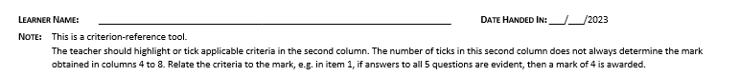

Byron Leukemans

# Appendix A continued…

# A black and white drawing of a person's face Description automatically generatedA document with text and numbers Description automatically generatedAppendix A: Assessment summary

17/07/2023

11/A

Roosevelt High School

Byron Leukemans

# A black and white drawing of a person's face Description automatically generatedAppendix B

17/07/2023

Help with the Design of the cover page

Help with the summaries of the document

Chloe Leukemans:

Shaun Leukemans

0602085195082

Byron Leukemans

# A black and white drawing of a person's face Description automatically generatedA close-up of a certificate Description automatically generatedAppendix B:Continued…

17/07/2023

# My Verdict on the topic

Though this sort of technology is still in a development stage, future consumers will need to wait a little. As discussed, we might see this roll out in the next 2-5 years as an estimation. Though many people's heads are still wrapped on the issues on AI, I believe that this is a total game changer and worth it. Not only will this redesign the future, but it will change the agriculture sector completely. In conclusion I would like to quote from infamous Steve Jobs: "Let's go invent tomorrow instead of worrying about what happened yesterday.

* [**Click here**](../Phase%202/Questionnaire%20on%20the%20use%20of%20Artificial%20Intelligence.xlsx) **to view the spreadsheet for phase 2**

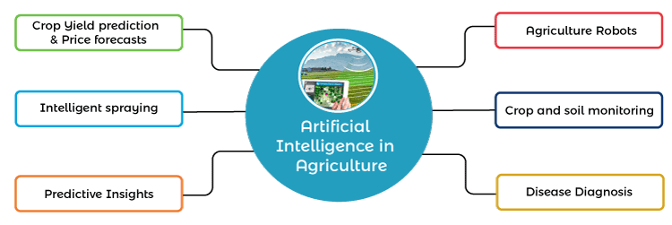

Figure Image showing the different types of technology Artificial Intelligence can offer for farmers